Software Requirements Specification
for
Orders and Overlays System
Version 1.0 approved
Prepared by Brendan
Unfair Advantage
20 AUG, 2020
Table of Contents
Table of Contents ii
Revision History ii
1. Introduction 1
1.1 Purpose 1
1.4 Product Scope 1
1.5 References 1
2. Overall Description 2
2.1 Product Perspective 2
2.2 Product Functions 2
2.3 User Classes and Characteristics 2
2.4 Operating Environment 2
2.5 Design and Implementation Constraints 2
2.6 User Documentation 2
2.7 Assumptions and Dependencies 3
3. External Interface Requirements 3
3.1 User Interfaces 3
3.2 Hardware Interfaces 3
3.3 Software Interfaces 3
3.4 Communications Interfaces 3
4. System Features 4
4.1 System Feature 1 4
4.2 System Feature 2 4
4.3 System Feature 3
5. Other Nonfunctional Requirements 4
5.1 Performance Requirements 4
5.2 Safety Requirements 5
5.3 Security Requirements 5
5.4 Software Quality Attributes 5
6. Other Requirements 5
Appendix A: Glossary 5
Appendix B: Analysis Models 5

Revision History
Name | Date | Reason For Changes | Version
Brendan | 20200720 | Creation

Introduction

Purpose
This SRS will address the functional requirements for release 1.0 of the Orders and Overlays System (OOS). This document is for use by the development team, contractors, and all other positions involved in OOS creations.

Document Conventions
This SRS will be a malleable product. Version control will be handled via Github.

Product Scope
The Orders and Overlays system seeks to combine all facets of Operations Orders creation into a single product, with a single system to use, view, change, provide analysis, version control, and orders approval.

References
APD 3-0 Operations
Military Terms and Graphics FM
Deliberate risk assessment

Overall Description

Product Perspective
Orders and Overlays System (OOS) will replace several pieces of software used to produce products Commanders and Staff need to craft timley orders. It will enable cross functional, inter-service, and interoperable functionality with NATO partners across all warfighting functions and specialty sections (UNCLASS).

Product Functions
This system will be dynamic and provide version control (like GitHub), word processing (like MS Word), and Overlays (like MS Power point) with built in restrictions

User Classes and Characteristics
The creator class will primarily be for tactical level leaders. This will begin at Staff Sergeant and run indefinitely through all echelons of leadership. Supervisor is intended to be the next immediate leader in the user’s chain of command, and their rater. The creator will be able to give rights to other content creators (other squad leaders, other Platoon leaders, other 1SGs and so on). These rights are given by either content creator or supervisor classes. Commander Class is reserved specifically for commanders at all levels. The Commander level required will be based on the deliberate risk assessment.

Operating Environment
Version 1.0 of the Orders and Overlays system will only work on Windows machines. Future versions will have certain functionality on GOV Iphones.

Design and Implementation Constraints
1.0 will be published to a single Brigade for tactical level orders production and publication.

User Documentation
User quick start guide
User in depth guide
NEC oversight guide

Assumptions and Dependencies
Satellite internet presents issues with connectivity. Field environments for tactical leader’s present creation issue. Units will need to ensure they are providing tactical leaders power, and internet capability to use they system.

User Interfaces
GUIs will function with dynamic inputs. The version control will show ALL versions of the product. Products, once signed, will be locked. These will be automatically archived.
The word processor will ONLY work in Operations Order format.
The overlays will have all graphic and overlay features from Military Terms and graphics will be imported. It will function as a drag and drop based on map size.

System Features

Orders

3.1.1 Description and Priority
The default format for orders production will be the Operations Order format. The processor will automatically provide numbering and sequencing.
3.1.2 Stimulus/Response Sequences
Clickable GUIs will enable quick indentations or numbering based on what portion of the OPORD the creator is on.
3.1.3 Functional Requirements
TBD

3.2.1 Description and Priority
Overlays based on Military terms and Graphics will be imported directly into the map functionality. This will provide graphical representation of the plan and execution. This system should not be used to validate surface danger zones.
3.2.2 Stimulus/Response Sequences
GUI will be drag and drop. There will be a search function to find specific graphics. All graphics will be sizeable and provide a 8 digit grid to locations on the application.
3.2.3 Functional Requirements

Other Nonfunctional Requirements

Performance Requirements
Computers will need to have at least 2015 and newer hardware and have no less than 8 GB of DDR4 RAM. The program can be web, and computer based. The program will need to have a print functionality.

Safety Requirements
This program is not intended to replace the risk assessment or surface danger zone deconfliction.

Security Requirements
Initial push of 1.0 will only be for UNCLASS orders without any PII.

Software Quality Attributes

Business Rules
The system will be UNCLASS but all user should have a clearance.

Other Requirements

Safety Requirements
This programs intent is to be used as a tool during the orders production process. It is not designed to be a catch-all in terms of use, safety, fires deconfliction, or coordination with units. Each of item of the orders production, execution which required deconfliction, warm-hand exchanges, or follow on requests for information are still required.

Security Requirements
All orders produced on this system will be UNCLASSIFIED. All elements of the order will be UNCLASSIFIED. No personal identifiable information, capabilities, or limitations will be mentioned in the orders created with this product. All INFOSEC and Information Assurance policies will be strictly adhered to.

Software Quality Attributes
All systems will be left on Tuesday into Wednesday. We will push updates during these hours and fix potential issues. Future versions and capabilities will be pushed during this time. Any system not functioning will be turned in for maintenance to their units Lucky American Gunfighter (LAG, llc.) contractor.

Business Rules
This product is intended to be utilized by the warfighter leadership at the tactical level. Sergeants through Majors will be the primary customer. Team and Squad Leaders plans will be vetted by their Platoon Sergeants, then Lieutenants on to the Company First Sergeants, and finally the Company Commander. Company Commanders will submit their approved orders to their respective Battalions Operations for viewing. Battalion Orders will be submitted to Brigade in the same manner. Creating the plan will done by those executing the plan, and approval and oversight provided by respective echelon Commanders.

Other Requirements
- Robust SQL database will be needed for documenting all changelogs and updates.
- All doctrine to be used will be available via opensource. \
- All users will have completed their annual cyber requirements. See unit guidance for more details.
- All grids will be MGRS with the correct inputs

Appendix A: Glossary
Glossary
Word | Description
OOS | Orders and overlay system
APD | Army Publishing Directorate
Echelon | level or layer of leadership
Github | software hosting service that provides dynamic ve
GOV | Denotes Government, normally possessive
GUI | Graphic user interface
INFOSEC | Information Security
MGRS | Military Grid Reference system
MS | Micro Soft
NATO | North Atlantic Treaty Organization
OPORD | Operations order
PII | Personally identifiable information
SQL | Structed Query Language

Appendix B: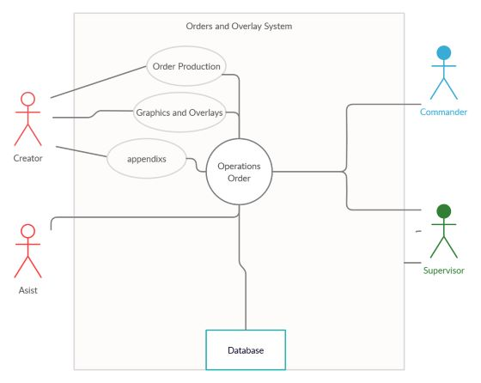
Appendix C: To Be Determined List

